COMPUTING LAB - II
ADVANCED SYSTEM SOFTWARE LAB - CSE 5261
MTech - CSE
Week - 3 Basics of Python Programming

Name : Rajat Jain
Reg No : 200913010

Lab Exercises:

1) Write a class called Investment with fields called principal and interest. The
constructor should set the values of those fields. There should be a method called value_after that returns the value of the investment after n years. The formula for this is p(1 + i)n, where p is the principal, and i is the interest rate. It should also use the special method __str__ so that printing the object will result in something like below:
Principal - $1000.00, Interest rate - 5.12%

Code

class investment:
def __init__(self,p,i):
self.principal = p
self.interest = i
def value_after(self,n):
value = self.principal*((1+self.interest)**n)
return value
def __str__(self):
return 'Principal - ${self.principal}, Interest rate - {self.interest}%'.format(self=self)

ob1 = investment(1000.00,5.12)
print(ob1)
print(f"The value after 5 years is {ob1.value_after(5)}")

Output

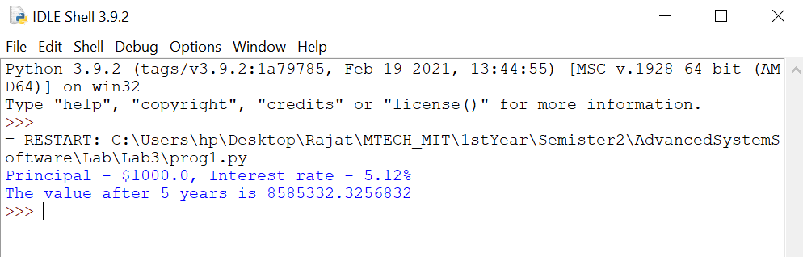

2) Write a class called Password_manager. The class should have a list called
old_passwords that holds all of the user’s past passwords. The last item of the list is the user’s current password. There should be a method called get_password that returns the current password and a method called set_password that sets the user’s password. The set_password method should only change the password if the attempted password is different from all the user’s past passwords. Finally, create a method called is_correct that receives a string and returns a Boolean True or False depending on whether the string is equal to the current password or not.

Code

class Password_manager:
def __init__(self,old) -> None:
self.old=old

def getPassword(self):
return self.old[len(self.old)-1]

def setPassword(self, newPw):
if newPw not in self.old:
self.old.append(newPw)
print("Password Updated")
else:
print("Entered password is an old password")
newPass=input("Enter the new password: ")
self.setPassword(newPass)
def is_correct(self,curPw):
if curPw == self.old[len(self.old)-1]:
return True
return False

old_passwords=['abc123','abc*123','abc@123','def123','def*123'] #last password is current password

ob1=Password_manager(old_passwords)

print("Executing get_password function")
print(f"The user's current password is : {ob1.getPassword()}")

print("Executing set_password function")
newPass=input("Enter the new password: ")
ob1.setPassword(newPass)

print("Executing is_correct function")
curPass=input("Enter current password: ")
if ob1.is_correct(curPass)==True:
print("Password Matched")
else:
print("Password Not Matched")

Output

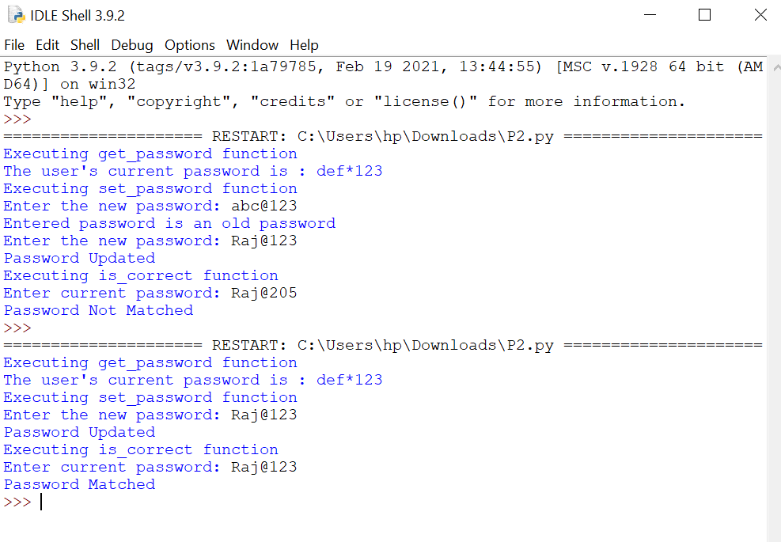

3) Write a class called Wordplay. It should have a field that holds a list of words. The user of the class should pass the list of words they want to use to the class. There should be the following methods:
• words_with_length(length) — returns a list of all the words of length length
• starts_with(s) — returns a list of all the words that start with s
• ends_with(s) — returns a list of all the words that end with s
• palindromes() — returns a list of all the palindromes in the list
• only(L) — returns a list of the words that contain only those letters in L
• avoids(L) — returns a list of the words that contain none of the letters in L

Code

class Wordplay:
def __init__(self,words):
self.words = words
def words_with_length(self,n):
return_list = []
for i in self.words:
if len(i)==n:
return_list.append(i)
return return_list
def starts_with(self,s):
return_list = []
for i in self.words:
if i[0]==str(s):
return_list.append(i)
return return_list
def ends_with(self,s):
return_list = []
for i in self.words:
if i[-1]==str(s):
return_list.append(i)
return return_list
def palindromes(self):
return_list = []
for i in self.words:
if i == i[::-1]:
return_list.append(i)
return return_list

def only(self,L):
return_list = []
for i in self.words:
match = True
for j in i:
if j not in L:
match = False
break
if match==True:
return_list.append(i)
return return_list
def avoids(self,L):
return_list = []
for i in self.words:
match = True
for j in i:
if j in L:
match = False
break
if match==True:
return_list.append(i)
return return_list
words = ['apple','ball','cat','dog','owl','bat','tat','pip']
ob1 = Wordplay(words)
print(f"Chosen words are : {words}")
print(f"The words with length 3 are : {ob1.words_with_length(3)}")
print(f"The words that start with 'b' are : {ob1.starts_with('b')}")
print(f"The words that ends with 't' are : {ob1.starts_with('t')}")
print(f"The words which are palindromes are : {ob1.palindromes()}")
print(f" The words which contains only the letters in ['t','a'] are : {ob1.only(['t','a'])}")
print(f"The words which contains none of the letters in ['p','b','w'] are : {ob1.avoids(['p','b','w'])}")

Output

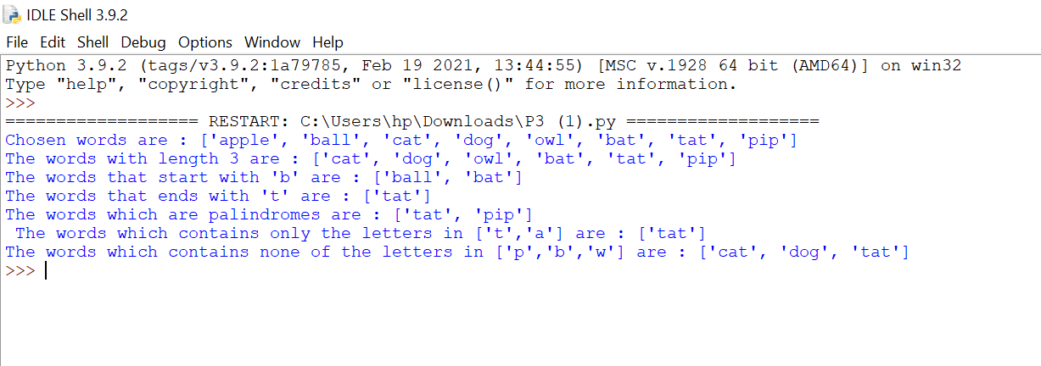

4) Write the regular expressions in Python for the following:
i) To replace all occurrences of abc with *.( Eg:- ‘abcdef’ replace to (‘abc’,’*’)
ii) To convert roman numerals into ordinary numbers.
iii) To recognize the strings: “bat,” “bit,” “but,” “hat,” “hit,” or “hut.”
iv) That converts to lowercase every capital letter that is followed by a
lowercase letter.

Code
import re
text = input("Enter the text")
text = re.sub('abc','*',text)
#print(text)
def romanToInt(rom):
value = {
'M': 1000,
'D': 500,
'C': 100,
'L': 50,
'X': 10,
'V': 5,
'I': 1
}

# Initialize previous character and answer
p = 0
ans = 0

# Traverse through all characters
n = len(rom)
for i in range(n-1, -1, -1):

# If greater than or equal to previous,
# add to answer
if value[rom[i]] >= p:
ans += value[rom[i]]

# If smaller than previous
else:
ans -= value[rom[i]]

# Update previous
p = value[rom[i]]

return ans

split_words = text.split(' ')
patt = r'[MDCLXVI]+$'
r = re.compile(patt)
roman_numeral = list(filter(r.match, split_words))
#print(roman_numeral)
for x in roman_numeral:
text = re.sub(x,str(romanToInt(x)),text)
#print(text)

patt = "[bh][aiu]t"

print("Recognized strings are : ")
print(re.findall(patt,text))

caps = re.findall("[A-Z][a-z]",text)
for x in caps:
replace = x.lower()
text = re.sub(x,replace,text)
print("Modified text is : ")
print(text)

Output

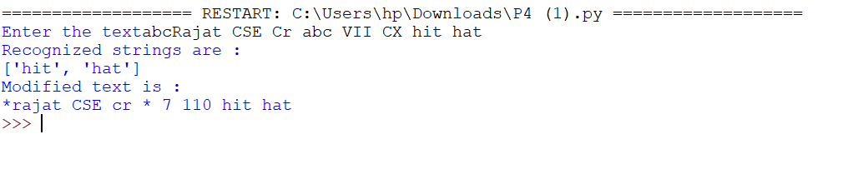

5) Write the functions in Python to sort a list of strings by length, rather than
alphabetically.

Code

str = [ "He is a person", "Apple", "Impossible", "There is ASSW class today"]
print("Input list: ")
print(str)
str.sort(key=len)
print("Sorted list(based on length): ")
print(str)

Output
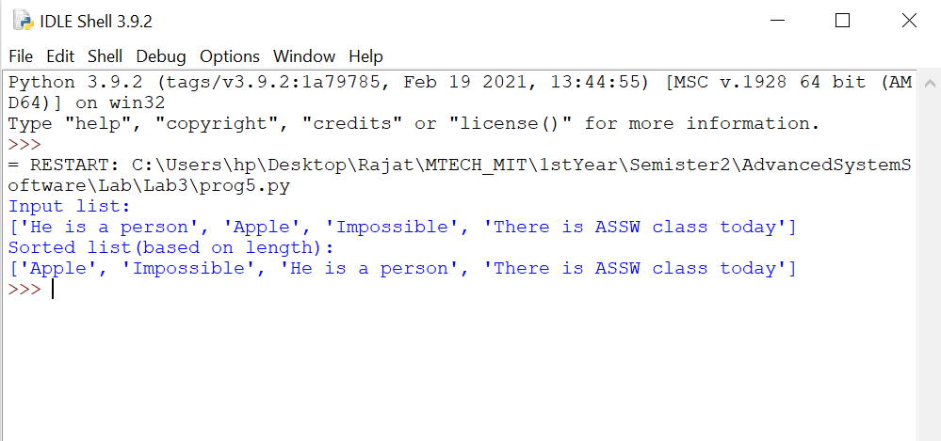

6) Write a program in Python, that removes single and multiline comments from
a given input ‘C’ file.

Code

import re
def removeComments(string):
string = re.sub(re.compile("/\*.*?\*/",re.DOTALL ) ,"" ,string) # remove all occurrences streamed comments (/*COMMENT */) from string
string = re.sub(re.compile("//.*?\n" ) ,"" ,string) # remove all occurrence single-line comments (//COMMENT\n ) from string
return string

with open('cprogram.c','r') as file:
text = file.read()
modified_program = removeComments(text)
print("C Program after removing the single line and multi-line comments : ")
print(modified_program)

Output

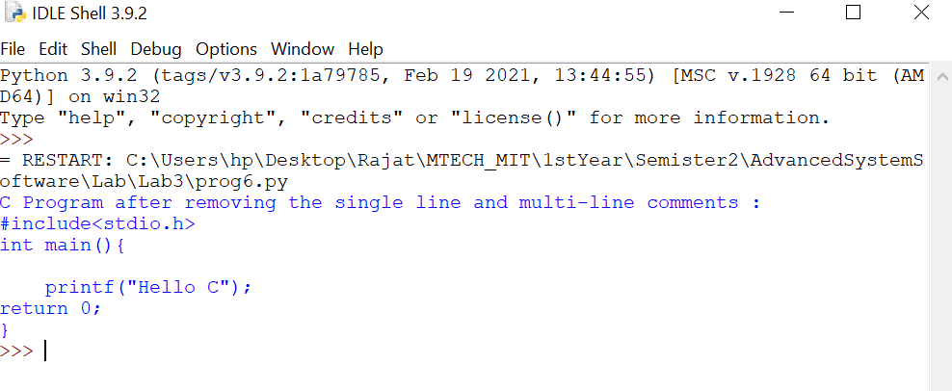
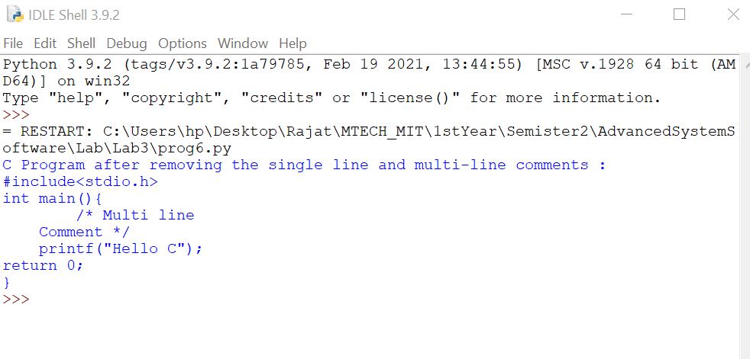

7) Write a program in Python, that takes a file as input and replaces blank
spaces and tabs by single space and writes the output to a file.

Code

fin = open("input.txt", "rt")
fout = open("output.txt", "wt")
for line in fin:
fout.write(' '.join(line.split()))
fin.close()
fout.close()

Output

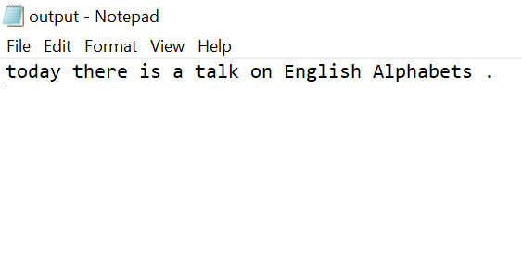

8) Write a program in Python, to match the set of all valid Python identifiers.

Code

import re

regex = '^[A-Za-z_][A-Za-z0-9_]*'

def check(string):

if(re.search(regex, string)):
print("Valid Identifier")

else:
print("Invalid Identifier")

if __name__ == '__main__' :

string = input("Enter String : ")

check(string)

Output

